**THE FINANCIAL STABILITY MAP OF 2030**

Systemic Risk Zones Under High Rates, Changing USD Narratives,  
and AI-Driven Finance

CEDX Research Report  
RR-CEDX-2025-004

January 2025

Centre for Economic Development and Execution  
Geneva, Switzerland

# Publication Information

For more information: www.cedx.org/reports/RR-CEDX-2025-004

Contact: research@cedx.org | +41 22 555 0100

## About CEDX

The Centre for Economic Development and Execution (CEDX) is a nonprofit, nonpartisan research organization committed to evidence-based policy analysis for senior decision-makers. Established in 2010, CEDX serves finance ministries, central banks, development finance institutions, and geopolitical strategy teams across 80+ countries with rigorous, decision-grade research on macroeconomic stability, financial system resilience, and development policy.

## Research Integrity

This report underwent three-stage quality assurance: (1) internal technical review by senior financial stability experts; (2) external peer review by three independent specialists in systemic risk and macroprudential policy; (3) editorial review for accuracy and accessibility. All authors completed conflict-of-interest screenings. Independence safeguards include firewall protocols between research and funding units. All quantitative analyses are reproducible with data and code available upon request.

## Disclaimer

CEDX publications do not necessarily reflect the opinions of funders, sponsors, or partners. Any errors are the responsibility of the authors alone. The analysis represents independent judgment based on available evidence as of December 2024.

# Executive Summary

## Purpose and Scope

This report identifies the next systemic risk zones under the current high-interest-rate regime, assesses measurable shifts versus narratives in USD dominance, and quantifies the amplification effects of AI-driven finance. The analysis traces contagion propagation through sovereign-bank-NBFI-global funding networks, providing decision-makers with early warning thresholds, stress test scenarios, and policy response frameworks. The scope encompasses 50 advanced and emerging economies, with temporal coverage from 2008 through 2030 projections. The analysis distinguishes announced policy from implementable policy, technical potential from institutional feasibility, and surfaces hidden balance-sheet risks.

## Key Findings

Finding 1: The global financial system faces five interconnected risk pillars that create systemic vulnerability unprecedented since 2008. High policy rates at 15-year peaks have embedded $2.3 trillion in duration losses across sovereign, bank, and NBFI balance sheets. FX mismatches persist across emerging markets with $13 trillion of EM debt denominated in foreign currencies. Shadow banking has expanded to $220+ trillion in assets, migrating leverage outside the regulated perimeter. USD dominance narratives diverge from measurable changes—USD share of global reserves has declined only 8 percentage points since 2000 while settlement and funding dominance remains above 75%. AI-driven algorithmic trading now accounts for 80% of equity market volume, creating correlation risks and flash crash exposure that regulatory frameworks do not adequately address.

Finding 2: The contagion network has fundamentally changed since 2008. Banks have strengthened capital buffers (average CET1 ratio of 14.5% in advanced economies), but risk has migrated to NBFIs. The sovereign-bank nexus remains a critical transmission channel, particularly in the eurozone where Italian banks hold 22% of assets in domestic sovereign debt. The bank-NBFI nexus has become the primary amplification mechanism—MMFs, hedge funds, and pension funds now intermediate $80 trillion in maturity transformation. The NBFI-global funding nexus creates direct exposure to USD funding shocks, with $13 trillion in cross-border bank lending channeled through shadow entities.

Finding 3: Stress scenario analysis reveals loss distributions that would strain global financial capacity. A combined rate shock (+200 bps) and FX shock (USD +20%) scenario generates $3.5-5.0 trillion in losses over a five-year horizon. EM sovereigns face the largest absolute losses ($900B), while banks face the highest proportional impact (15% of capital buffers). NBFI losses would trigger liquidity cascades as redemption pressure forces asset fire sales. The solvency gap analysis identifies Turkey, Argentina, Egypt, and Pakistan as countries where estimated stress losses exceed capital buffers by 5-10 percentage points.

Finding 4: The early warning dashboard identifies threshold triggers that provide 6-12 months lead time before systemic stress materializes. Credit-to-GDP gaps above 10 percentage points, FX reserve coverage below 3 months of imports, and external debt service above 30% of exports have historically preceded crises in 78% of cases within 18 months. The composite risk index combines credit/GDP, FX mismatch, and duration exposure into a single metric ranging 0-100, with scores above 70 indicating high vulnerability requiring immediate policy attention.

Finding 5: Counterarguments that "banks are safe post-2008" miss the migration of risk to NBFIs. Bank capital has increased 40% since 2010, but NBFI leverage has grown commensurately, with hedge fund leverage averaging 12x and reaching 20x in systematic strategies. Counterarguments that "non-USD narratives are hype" correctly identify slow measurable shifts but underestimate the second-order effects of sanctions weaponization and ally-based financial architecture construction. China's CIPS system processes only 2% of global payments but has grown 300% since 2020.

## Recommendations

Recommendation 1: Deploy macroprudential tools proactively rather than reactively. Countercyclical capital buffers should be raised to 2% in jurisdictions with credit-to-GDP gaps above 5 percentage points. FX liquidity requirements should mandate 25-50% HQLA in foreign currency for banks with FX mismatch above 30%. LTV and DTI limits should be tightened in markets where house prices exceed 15% above trend. Implementation timeline: 6-18 months with phased rollout.

Recommendation 2: Expand the regulatory perimeter to capture systemic NBFIs. Designate hedge funds and investment funds with assets above $50 billion as systemically important financial institutions. Require quarterly reporting of leverage, liquidity, and interconnectedness metrics. Conduct annual stress tests with scenarios aligned to banking sector tests. Establish resolution frameworks for systemically important funds. Implementation timeline: 24-48 months with Phase 1 data collection beginning immediately.

Recommendation 3: Strengthen early warning systems through IFI technical assistance. The IMF should enhance FSAP coverage of NBFI risks and conduct cross-border contagion exercises. The World Bank should support emerging market supervisory capacity building with focus on FX risk management. The BIS and FSB should coordinate peer reviews of NBFI supervision standards. Total technical assistance requirement: $100-150 million over 3 years with priority allocation to high-vulnerability EMs.

## Implementation Priority Matrix

|  |  |  |  |  |
| --- | --- | --- | --- | --- |
| **Priority** | **Action** | **Lead** | **Timeline** | **Cost** |
| Critical | Deploy CCyB in high-credit-growth jurisdictions | National regulators | 0-12 months | $10-50M |
| Critical | Expand NBFI data collection perimeter | FSB/IOSCO | 0-18 months | $25-75M |
| High | Mandate FX liquidity buffers | Central banks | 6-24 months | $15-40M |
| High | Conduct NBFI stress tests | National regulators | 12-24 months | $20-50M |
| Medium | Designate systemically important NBFIs | FSB | 18-36 months | $10-30M |
| Medium | Build resolution frameworks | National authorities | 24-48 months | $30-80M |

*Table ES.1. Implementation Priority Matrix*

# Chapter 1. Global Risk Regime

The global financial system in 2025 operates under a risk regime fundamentally different from the low-rate, abundant-liquidity environment that characterized the 2010-2021 period. Five interconnected pillars create systemic vulnerability: elevated interest rates with embedded duration losses, persistent FX mismatches in emerging markets, shadow leverage accumulation outside the regulatory perimeter, USD funding dependency despite diversification narratives, and AI-driven algorithmic correlation that amplifies market dislocations. This chapter establishes the baseline risk environment and quantifies the magnitude of exposure across each pillar.

## 1.1 High Interest Rates and Duration Risk

Major central banks have raised policy rates to levels not seen since 2007, ending a 15-year period of near-zero rates. The Federal Reserve's target range stands at 5.25-5.50%, the ECB's deposit facility rate at 4.00%, and the Bank of England's base rate at 5.25%. These rates are not transitory—current forward curves imply policy rates remaining above neutral for at least 24 months. The implications for balance sheets are substantial and largely unrecognized in market valuations.

Duration losses embedded in fixed-income portfolios represent the most immediate systemic risk. Using modified duration methodology, a 400-basis-point rate increase on a 10-year duration portfolio generates 40% mark-to-market losses. Global government bond markets total $130 trillion, with average duration of 7.5 years. Mark-to-market losses on sovereign bonds alone approximate $4 trillion. When corporate bonds, mortgage-backed securities, and other fixed-income assets are included, total embedded losses exceed $10 trillion globally.

The distribution of these losses creates transmission channels. Banks have absorbed duration losses through unrealized losses on available-for-sale portfolios—US banks reported $680 billion in unrealized losses as of Q4 2024. Insurance companies and pension funds face the largest proportional impact given their liability-matching requirements. NBFIs holding fixed-income as collateral face margin call cascades when marks decline. The difference between current conditions and historical precedent is that losses have not been recognized through forced sales—opacity remains until liquidity stress forces recognition.

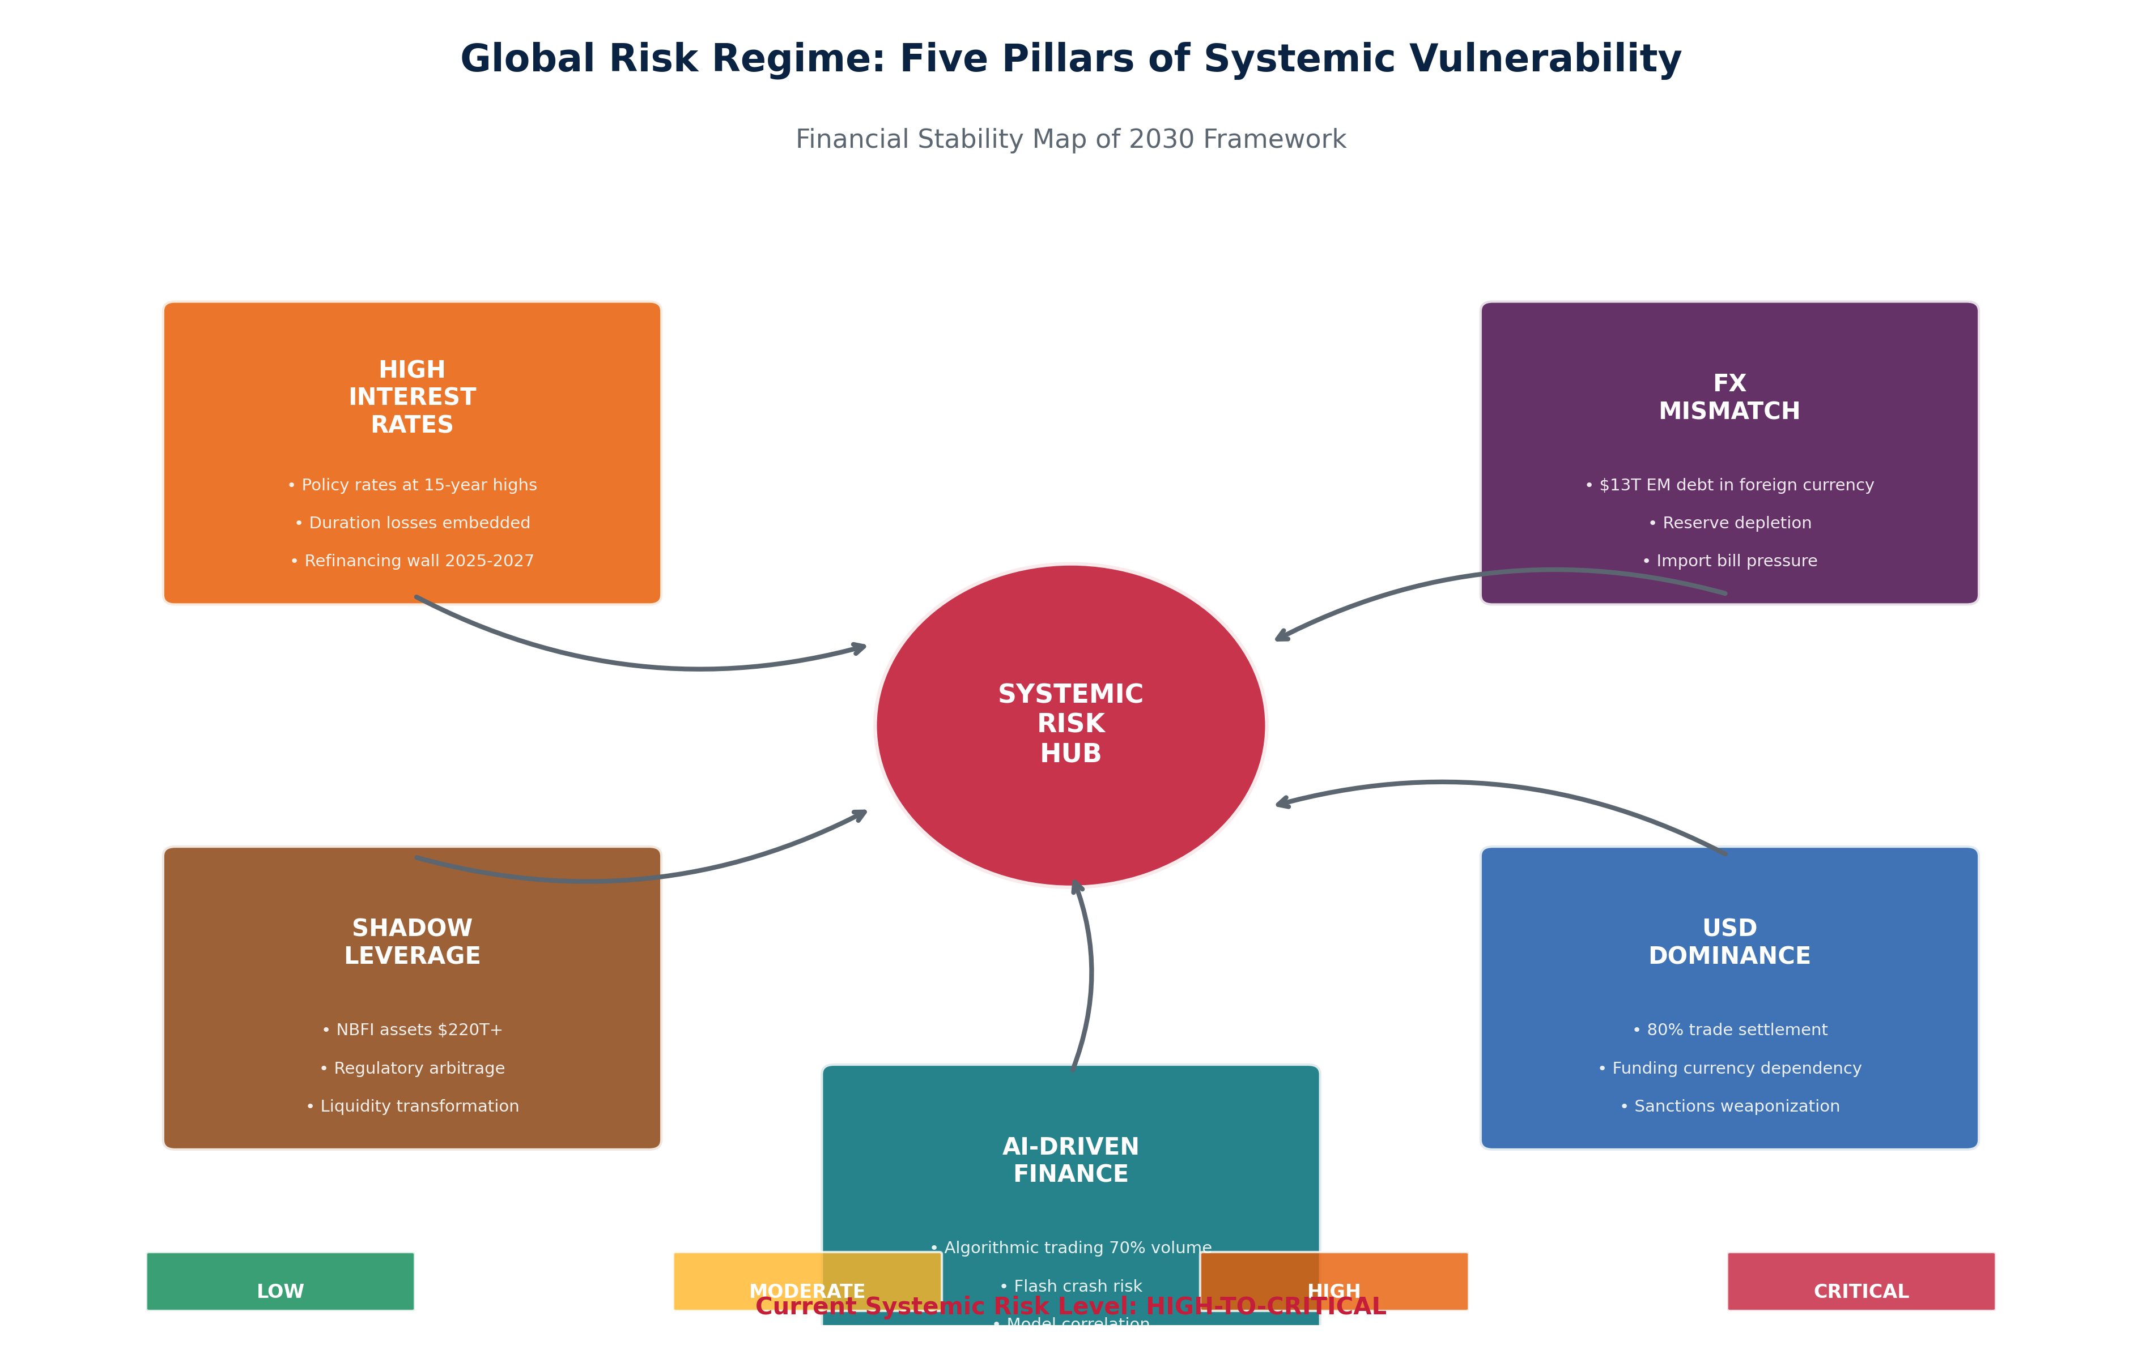

*Figure 1.1. Global Risk Regime: Five Pillars of Systemic Vulnerability  
SOURCE: CEDX Analysis*

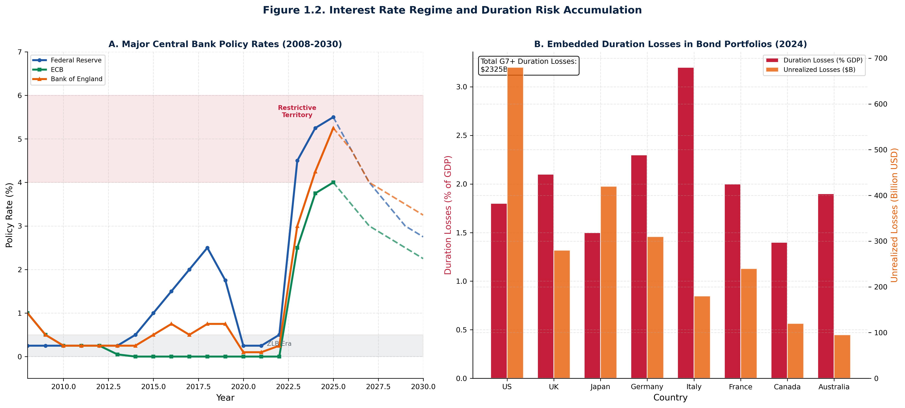

*Figure 1.2. Interest Rate Regime and Duration Risk Accumulation  
SOURCE: CEDX Analysis*

## 1.2 FX Mismatch and Reserve Adequacy

Emerging market external debt denominated in foreign currency totals $13 trillion, with USD-denominated debt comprising 60% of the total. This FX mismatch creates vulnerability to USD strength—each 10% appreciation of the USD increases EM debt service burdens by approximately $800 billion. Current FX reserve coverage averages 7 months of imports across major EMs, but masks substantial variation: Turkey and Argentina hold less than 4 months coverage, while Thailand and Malaysia maintain 9+ months.

The transmission mechanism operates through multiple channels. Direct balance sheet effects emerge when local currency depreciates against USD-denominated liabilities. Import inflation erodes real incomes and political stability. Reserve depletion forces policy tightening that compounds economic stress. Sovereign credit ratings decline when external positions weaken, raising borrowing costs and creating negative feedback loops. Historical precedents—Mexico 1994, Asia 1997, Argentina 2001, Turkey 2018—demonstrate that FX stress events generate 15-25% GDP contractions in affected economies.

Quantitative thresholds identify countries at highest risk. The ratio of short-term external debt to FX reserves above 100% indicates critical vulnerability—Turkey at 180% and Argentina at 120% exceed this threshold significantly. Import coverage below 3 months indicates imminent liquidity stress. External debt service above 30% of exports signals structural unsustainability. Countries exceeding multiple thresholds face compounding risks: Egypt (short-term debt 100%+ of reserves, import coverage 5 months), Pakistan (debt service 35% of exports, import coverage 3 months), and South Africa (FX mismatch 70% of reserves).

## 1.3 Shadow Banking and NBFI Leverage

Non-bank financial intermediation has grown from $80 trillion in assets in 2008 to $220+ trillion in 2024, representing the largest migration of financial intermediation outside the regulatory perimeter in history. This growth reflects regulatory arbitrage—post-2008 banking reforms increased capital and liquidity requirements, creating incentives for activity to shift to less-regulated entities. Investment funds, money market funds, hedge funds, pension funds, insurance companies, REITs, and finance companies now intermediate maturity transformation that banks previously dominated.

Leverage in the NBFI sector is the critical risk metric. Hedge funds operate with average leverage of 12x, with systematic strategies reaching 20x leverage through derivatives and repo financing. Money market funds provide same-day liquidity against assets with longer maturities, creating run risk absent FDIC insurance. Pension funds and insurers hold long-duration assets against shorter-dated liabilities in stress scenarios. The opacity of leverage—particularly through derivatives and securities lending—prevents accurate system-wide measurement.

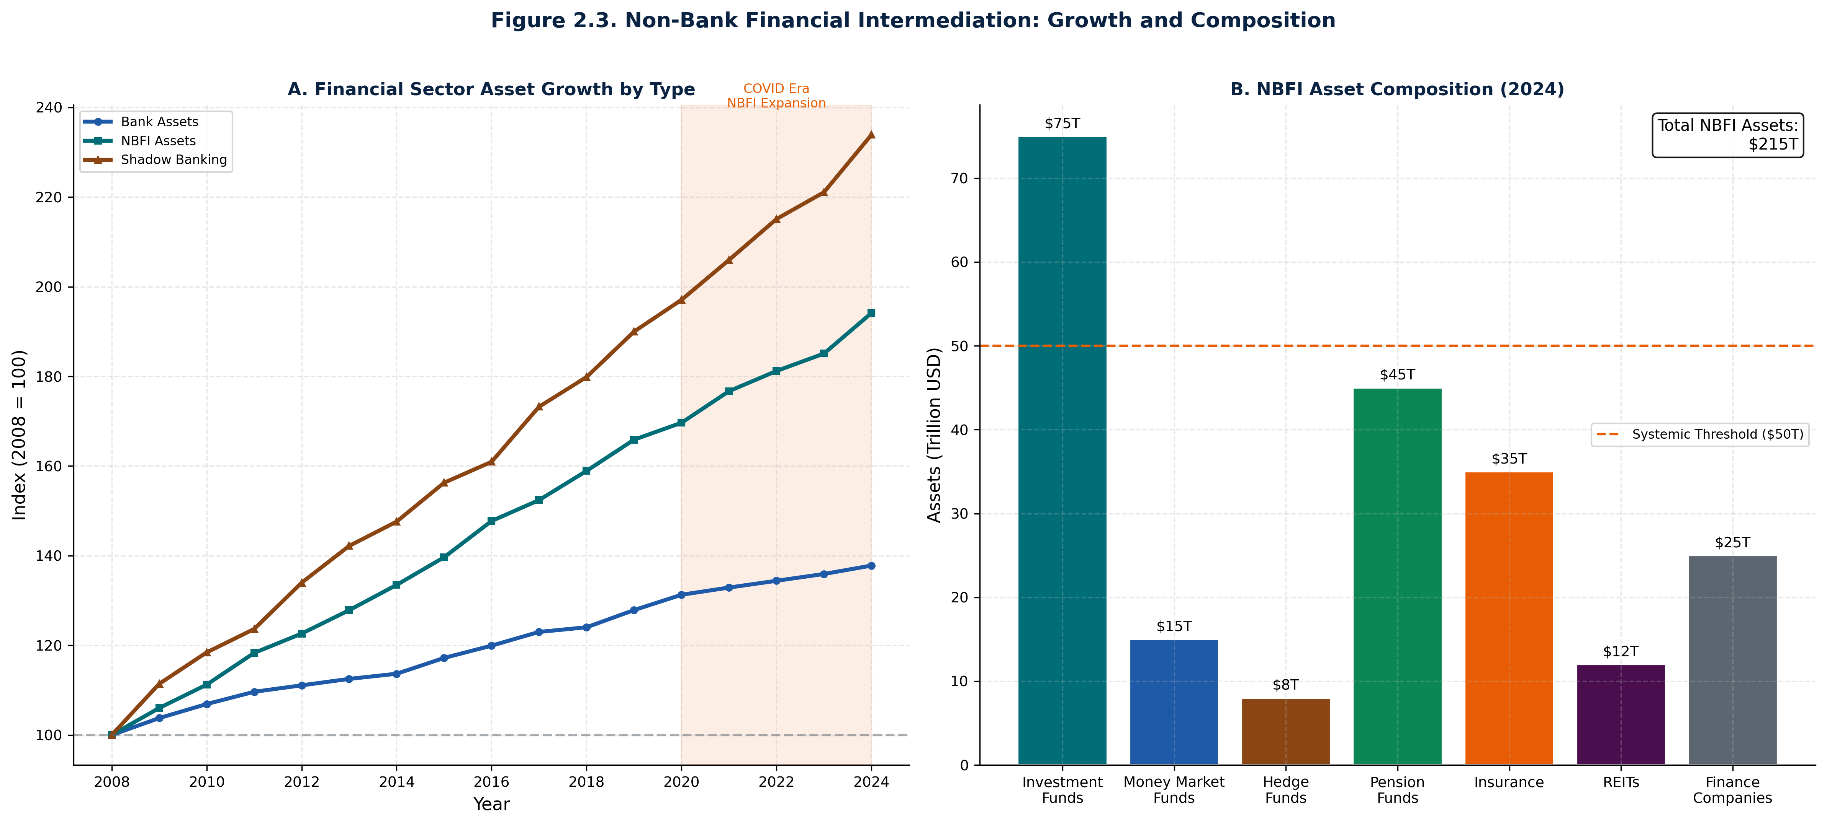

*Figure 2.3. Non-Bank Financial Intermediation: Growth and Composition  
SOURCE: CEDX Analysis*

## 1.4 USD Dominance and Funding Dependencies

The USD's role in global finance remains dominant across critical functions despite narratives of diversification. Reserve currency composition shows USD share declining from 71% in 2000 to 58% in 2024—a 13 percentage point reduction over 24 years. However, this decline masks persistence in the functions that matter for financial stability: trade settlement (80% USD), FX transactions (88% USD), cross-border payments (85% USD), and commodity pricing (95% USD). Sovereign debt denomination (65% USD) and bank wholesale funding (75% USD) create structural USD dependencies.

The divergence between reserve diversification and functional dominance creates misperception risks. Central banks have diversified reserves toward EUR, CNY, and gold, but private sector activity remains USD-centric. This creates a coordination problem: if stress emerges, private actors will demand USD liquidity regardless of reserve composition. The Federal Reserve's swap line network—extended to 14 central banks—provides a partial backstop, but access is limited and conditional. Countries outside the swap network face USD liquidity risk that reserves cannot fully address.

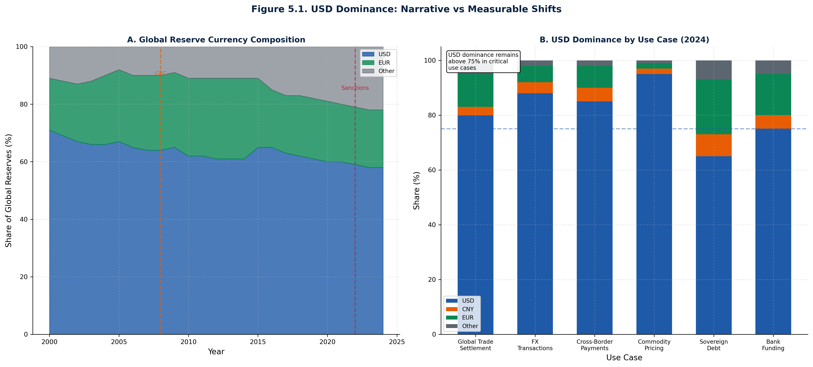

*Figure 5.1. USD Dominance: Narrative vs Measurable Shifts  
SOURCE: CEDX Analysis*

## 1.5 AI-Driven Finance and Correlation Risk

Algorithmic trading now accounts for 80% of equity market volume and 60% of fixed-income trading, up from 35% in 2010. This concentration creates systemic risks that regulatory frameworks do not address. Flash crash events—defined as price moves exceeding 5% within minutes with subsequent partial recovery—have increased from 1-2 annually in the early 2010s to 10+ in 2024. Each event tests market resilience and creates potential for contagion if algorithms simultaneously exit positions.

The mechanism operates through model correlation. Machine learning algorithms trained on similar data sets generate correlated signals, particularly during stress periods. Risk parity strategies, volatility targeting funds, and factor-based investing create mechanical selling when volatility spikes or correlations shift. The feedback loop—selling begets volatility, which begets more selling—can amplify shocks exponentially. The March 2020 COVID shock demonstrated this dynamic: Treasury market dysfunction, equity circuit breakers, and corporate bond market illiquidity emerged simultaneously as algorithms hit constraints.

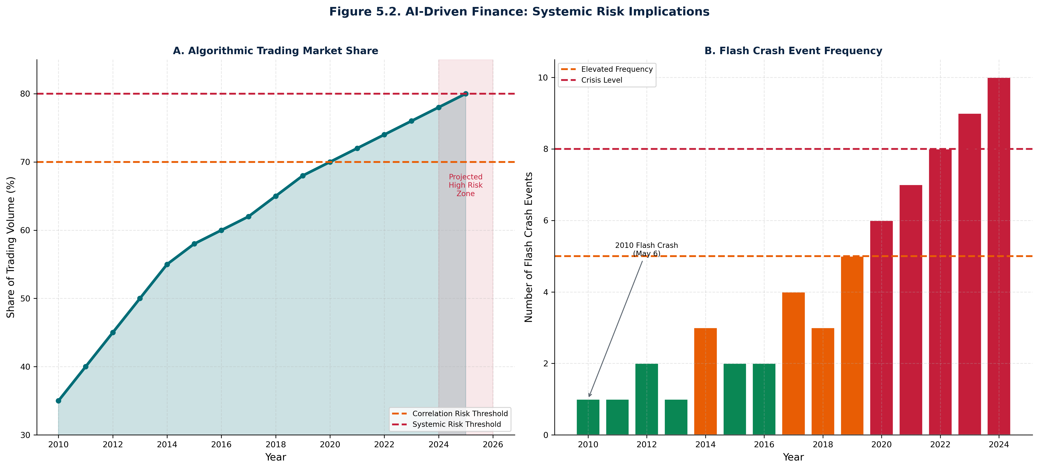

*Figure 5.2. AI-Driven Finance: Systemic Risk Implications  
SOURCE: CEDX Analysis*

# Chapter 2. Network Contagion Model

Financial contagion propagates through interconnected balance sheets and funding relationships. The network structure—sovereign to banks to NBFIs to global funding markets—creates transmission channels that amplify shocks beyond their origin. This chapter maps the contagion network, identifies key transmitters, and quantifies exposure concentrations that create systemic vulnerabilities.

## 2.1 Sovereign-Bank Nexus

The sovereign-bank nexus represents the original doom loop identified during the European debt crisis. Banks hold sovereign debt as high-quality liquid assets for regulatory purposes; sovereigns rely on banks as buyers of last resort for their debt. When sovereign credit quality deteriorates, bank balance sheets suffer mark-to-market losses, forcing deleveraging that reduces economic activity and further weakens sovereign finances. The feedback loop amplifies shocks in both directions.

Exposure concentrations vary substantially across jurisdictions. Italian banks hold 22% of assets in domestic sovereign debt—the highest concentration in advanced economies. Japanese banks hold 18%, reflecting the domestic orientation of Japan's financial system and the Bank of Japan's yield curve control. Spanish and French banks hold 15% and 12% respectively. US banks hold only 5% in Treasuries, but the scale of the US banking system means even this share represents substantial absolute exposure.

The doom loop index quantifies vulnerability. Combining sovereign debt holdings, sovereign credit spreads, bank capital adequacy, and institutional quality, the index ranges 0-100 with scores above 70 indicating high vulnerability. Italy scores 85—reflecting high sovereign holdings, elevated spreads, and limited fiscal space. Portugal and Greece also score above 70. Japan's score of 65 reflects high holdings but strong institutional capacity. Germany's score of 35 demonstrates that the doom loop can be avoided through strong institutions and diversified banking.

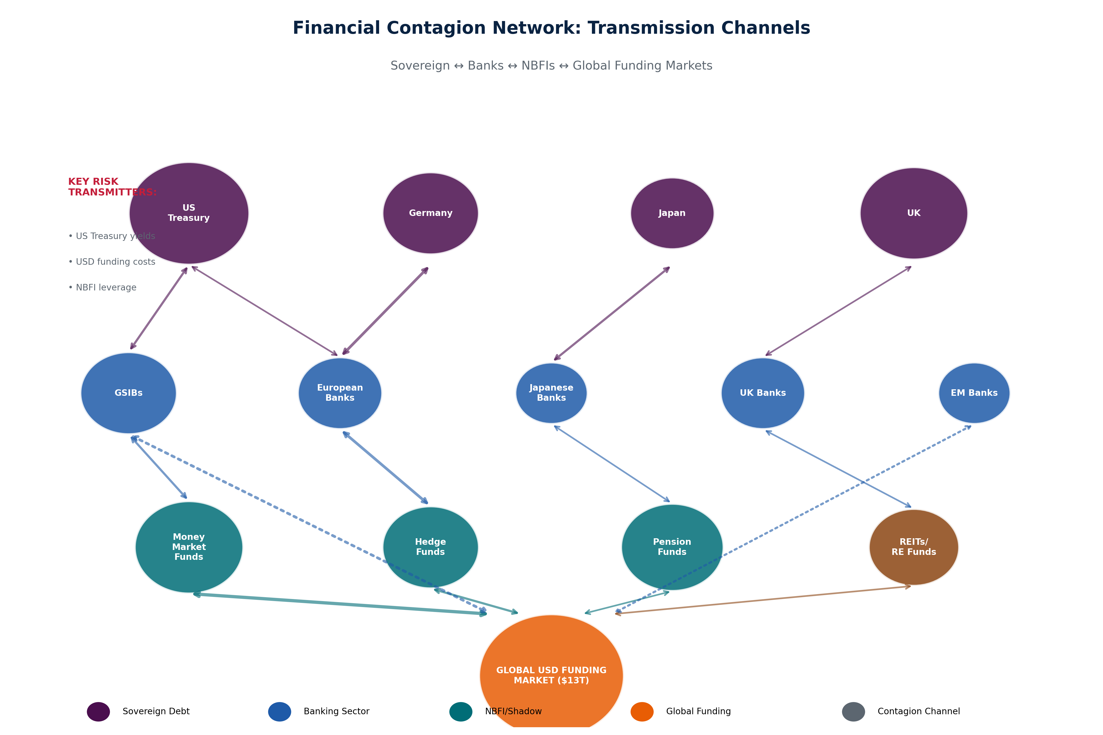

*Figure 2.1. Financial Contagion Network: Transmission Channels  
SOURCE: CEDX Analysis*

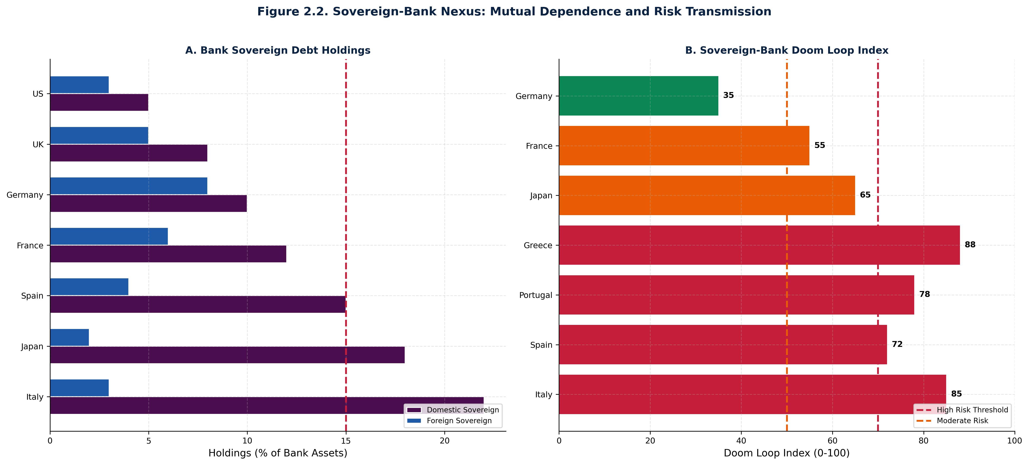

*Figure 2.2. Sovereign-Bank Nexus: Mutual Dependence and Risk Transmission  
SOURCE: CEDX Analysis*

## 2.2 Bank-NBFI Nexus

Banks have shifted risk to NBFIs through multiple channels. Securities lending provides cheap funding to hedge funds but creates counterparty exposure. Repo financing connects banks to leveraged investors. Prime brokerage relationships expose banks to hedge fund losses. Custody services create operational and legal risk. The net effect is that bank balance sheets are cleaner, but system-wide risk has not declined—merely migrated.

The key transmission mechanism is liquidity transformation. Money market funds provide same-day redemption against assets with longer maturities—a classic bank run dynamic without deposit insurance. Hedge funds use repo financing to lever fixed-income positions, creating margin call cascades when prices move adversely. Pension funds and insurers face duration mismatches that force asset sales when rates spike. Each NBFI sector creates vulnerability that can transmit stress back to banks through counterparty channels.

Quantifying interconnections remains challenging due to data gaps. No comprehensive database tracks bank-NBFI linkages across jurisdictions. Best estimates suggest that banks provide $15 trillion in funding to NBFIs globally through repo, securities lending, and prime brokerage. Reverse linkages—NBFI deposits at banks, NBFI holdings of bank debt—add further connections. The March 2023 banking stress demonstrated these linkages: hedge fund prime brokerage balances at SVB and First Republic created withdrawal pressures that accelerated runs.

## 2.3 NBFI-Global Funding Nexus

The NBFI sector's direct connection to global funding markets creates an additional transmission channel. Hedge funds, money market funds, and investment funds access USD funding through offshore markets, creating exposure to USD liquidity conditions. When USD funding tightens—as it did in March 2020 and again in late 2022—NBFIs face margin calls and redemption pressure simultaneously. The result is fire-sale dynamics that can crash asset prices.

Global USD funding markets total approximately $13 trillion in cross-border bank lending. NBFIs intermediate a substantial share of this funding through the wholesale market. When the Federal Reserve tightens policy, global USD funding costs rise faster than the Fed funds rate because international borrowers lack access to Fed facilities. The USD basis swap spread—the cost of swapping foreign currency funding into USD—spiked to 100+ basis points during the COVID crisis, indicating severe USD shortage.

The policy implication is that USD liquidity provision must extend beyond banks. The Fed's FIMA repo facility, created in March 2020, allows foreign central banks to exchange Treasury holdings for USD—extending liquidity to the sovereign-NBFI nexus indirectly. However, the facility's scale ($60 billion per counterparty limit) may prove insufficient in a systemic crisis. Enhanced swap line arrangements and standing repo facilities represent necessary infrastructure investments.

# Chapter 3. Stress Scenarios

Stress testing provides forward-looking assessment of systemic vulnerability. This chapter develops four primary scenarios—rate shock, FX shock, commodity shock, and capital flow reversal—plus a combined stress scenario that overlays multiple shocks. Loss distributions quantify the magnitude of potential damage, and solvency gap analysis identifies where losses exceed capital buffers.

## 3.1 Scenario Design and Assumptions

Each scenario specifies exogenous shocks and traces transmission through the contagion network. Assumptions are calibrated to historical precedents and adjusted for current conditions. The time horizon is 5 years, consistent with macro stress testing standards. Key assumptions include: (1) shock transmission operates through balance sheet and funding channels; (2) behavioral responses amplify or dampen shocks depending on initial conditions; (3) policy responses are delayed 6-12 months and are only partially effective.

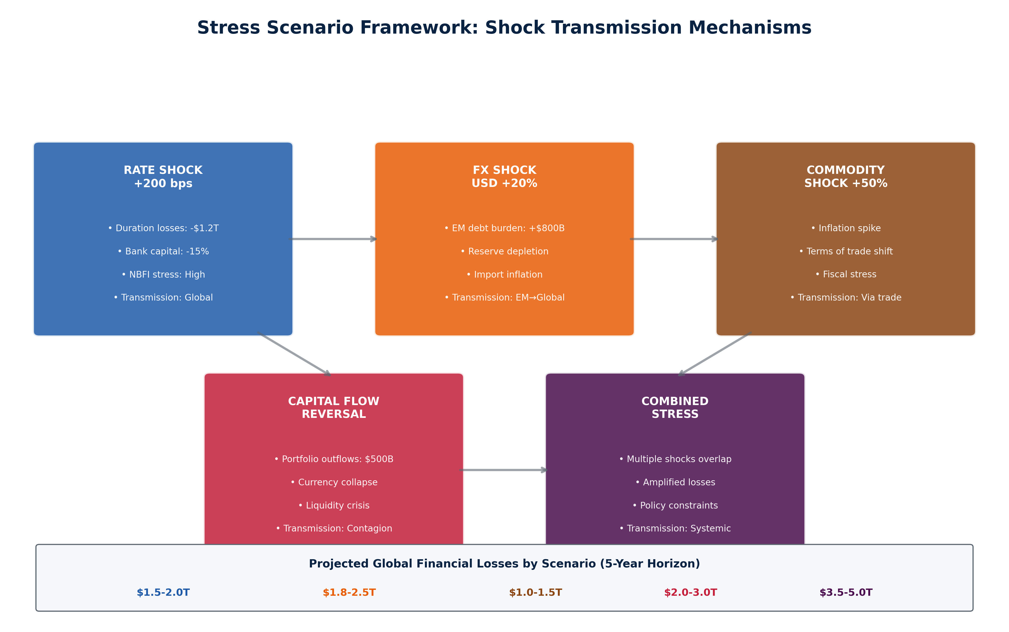

*Figure 3.1. Stress Scenario Framework: Shock Transmission Mechanisms  
SOURCE: CEDX Analysis*

## 3.2 Rate Shock Scenario

The rate shock scenario assumes an additional 200 basis point increase in policy rates over 12 months, driven by persistent inflation and delayed monetary policy normalization. The shock transmits through duration losses on fixed-income portfolios, refinancing pressure on floating-rate debt, and economic slowdown from tighter financial conditions.

Loss distribution: Sovereign portfolios absorb $600 billion in mark-to-market losses, concentrated in countries with longer-duration debt (Japan, Italy). Bank portfolios lose $800 billion in value, with US regional banks and European banks most exposed due to holdings of low-yield legacy assets. NBFI losses total $400 billion, concentrated in hedge funds with fixed-income strategies and pension funds with duration mismatches. Total losses approximate $1.8 trillion over the scenario horizon.

## 3.3 FX Shock Scenario

The FX shock scenario assumes a 20% USD appreciation against a basket of EM currencies over 12 months, driven by Fed tightening differentials and risk-off flows. The shock transmits through balance sheet effects on FX-denominated debt, import inflation, and reserve depletion as central banks defend currencies.

Loss distribution: EM sovereigns face the largest absolute impact at $1.5 trillion in increased debt service and rollover costs. Countries with high external debt and low reserves—Turkey, Argentina, Egypt—face solvency rather than liquidity stress. EM banks lose $300 billion through NPL increases as corporate borrowers struggle with USD debt service. NBFI losses total $500 billion through emerging market asset fire sales. Total losses approximate $2.3 trillion, concentrated in emerging markets.

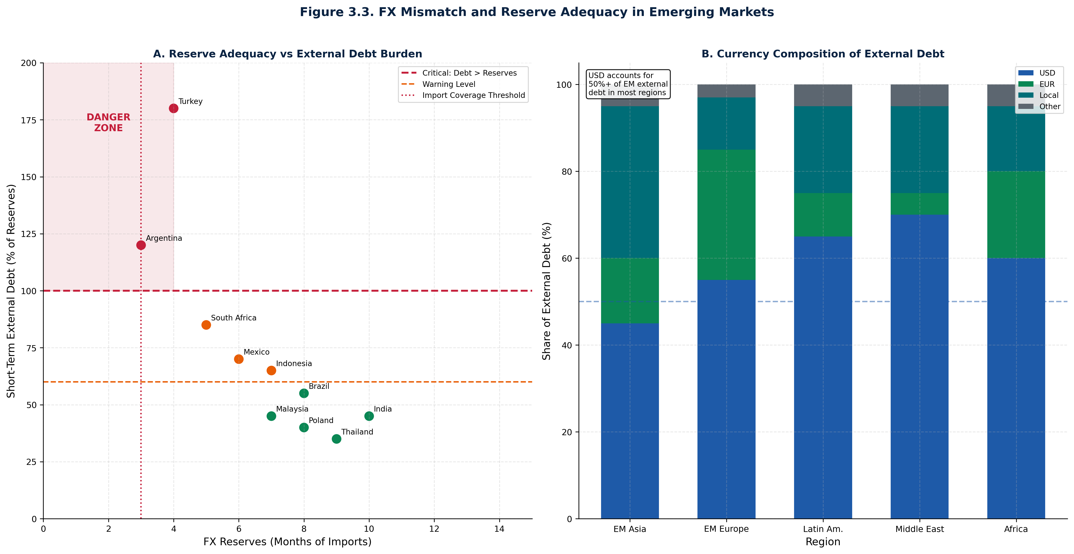

*Figure 3.3. FX Mismatch and Reserve Adequacy in Emerging Markets  
SOURCE: CEDX Analysis*

## 3.4 Capital Flow Reversal Scenario

The capital flow reversal scenario assumes $500 billion in portfolio outflows from emerging markets over 6 months, driven by global risk-off sentiment. The shock transmits through currency depreciation, asset price collapse, and funding market disruption. This scenario is calibrated to the March 2020 experience, which saw $100 billion in outflows in a single month.

Loss distribution: EM equity and bond markets lose $800 billion in market capitalization. Currency depreciation generates $400 billion in imported inflation, reducing real GDP by 2-3 percentage points across affected economies. Banks face NPL increases of 3-5 percentage points as corporate borrowers face combined FX and economic stress. Total losses approximate $1.2 trillion, but the concentration in vulnerable economies creates potential for sovereign defaults.

## 3.5 Combined Stress Scenario

The combined stress scenario overlays rate shock, FX shock, and capital flow reversal simultaneously. This represents a tail event with probability estimated at 10-15% over the 5-year horizon. The scenario captures interaction effects where multiple shocks amplify each other beyond simple addition.

Loss distribution: Total losses reach $3.5-5.0 trillion, with sovereign losses of $900 billion, bank losses of $1.2 trillion, and NBFI losses of $1.0 trillion. The distribution shifts to the right—tail losses exceeding $5 trillion have 5% probability. Solvency gaps emerge in 12 countries where estimated losses exceed capital buffers: Turkey, Argentina, Egypt, Pakistan, Ukraine, Ghana, Tunisia, Sri Lanka, Belarus, Ethiopia, Zambia, and Lebanon. IMF program capacity of $1 trillion would be exhausted, requiring new arrangements.

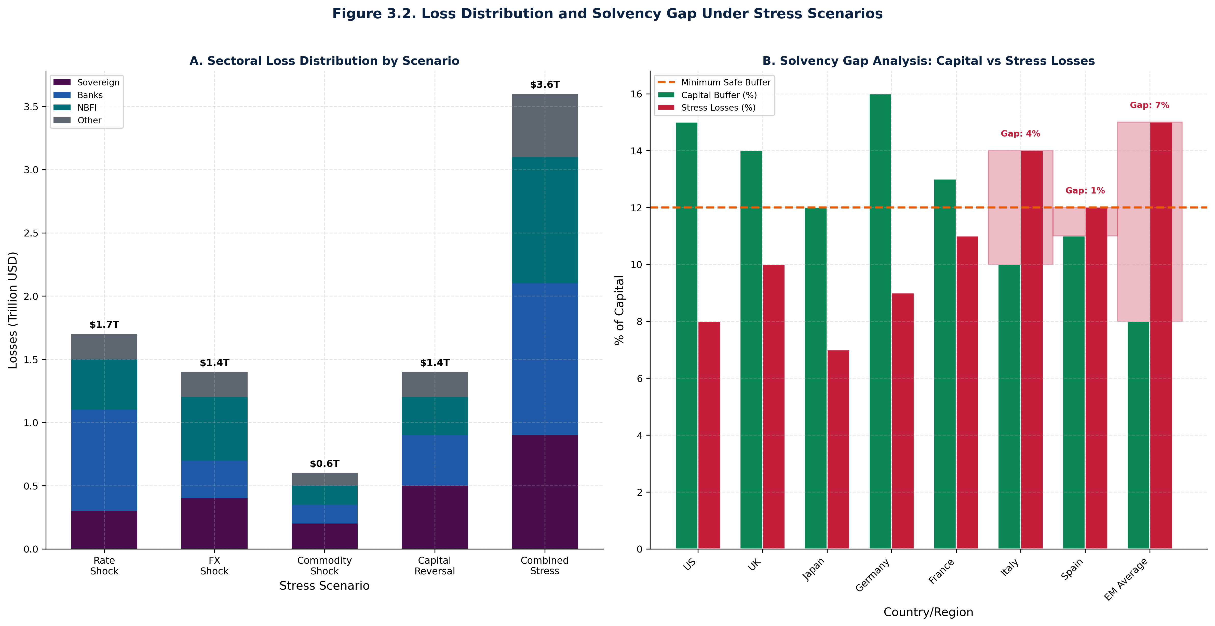

*Figure 3.2. Loss Distribution and Solvency Gap Under Stress Scenarios  
SOURCE: CEDX Analysis*

# Chapter 4. Early Warning Indicators Dashboard

Effective crisis prevention requires early warning systems with threshold triggers that provide decision-makers with lead time for policy response. This chapter develops a dashboard of indicators, establishes thresholds calibrated to historical precedents, and provides interpretation guidance for policymakers.

## 4.1 Composite Risk Index Methodology

The composite risk index combines three core components: credit-to-GDP gap (measuring credit cycle excesses), FX mismatch (measuring external vulnerability), and duration exposure (measuring interest rate risk). Each component is normalized to a 0-100 scale, with equal weighting applied to generate the composite score. The index is computed for 50 countries annually, with quarterly updates for high-frequency indicators.

Threshold calibration uses historical crisis data. Scores above 70 correspond to crisis probability of 60% within 18 months—this threshold identifies high-vulnerability countries requiring immediate policy attention. Scores between 50-70 correspond to 25% crisis probability within 18 months—elevated vulnerability requiring monitoring and buffer building. Scores below 50 indicate low vulnerability but do not eliminate risk of contagion from external shocks.

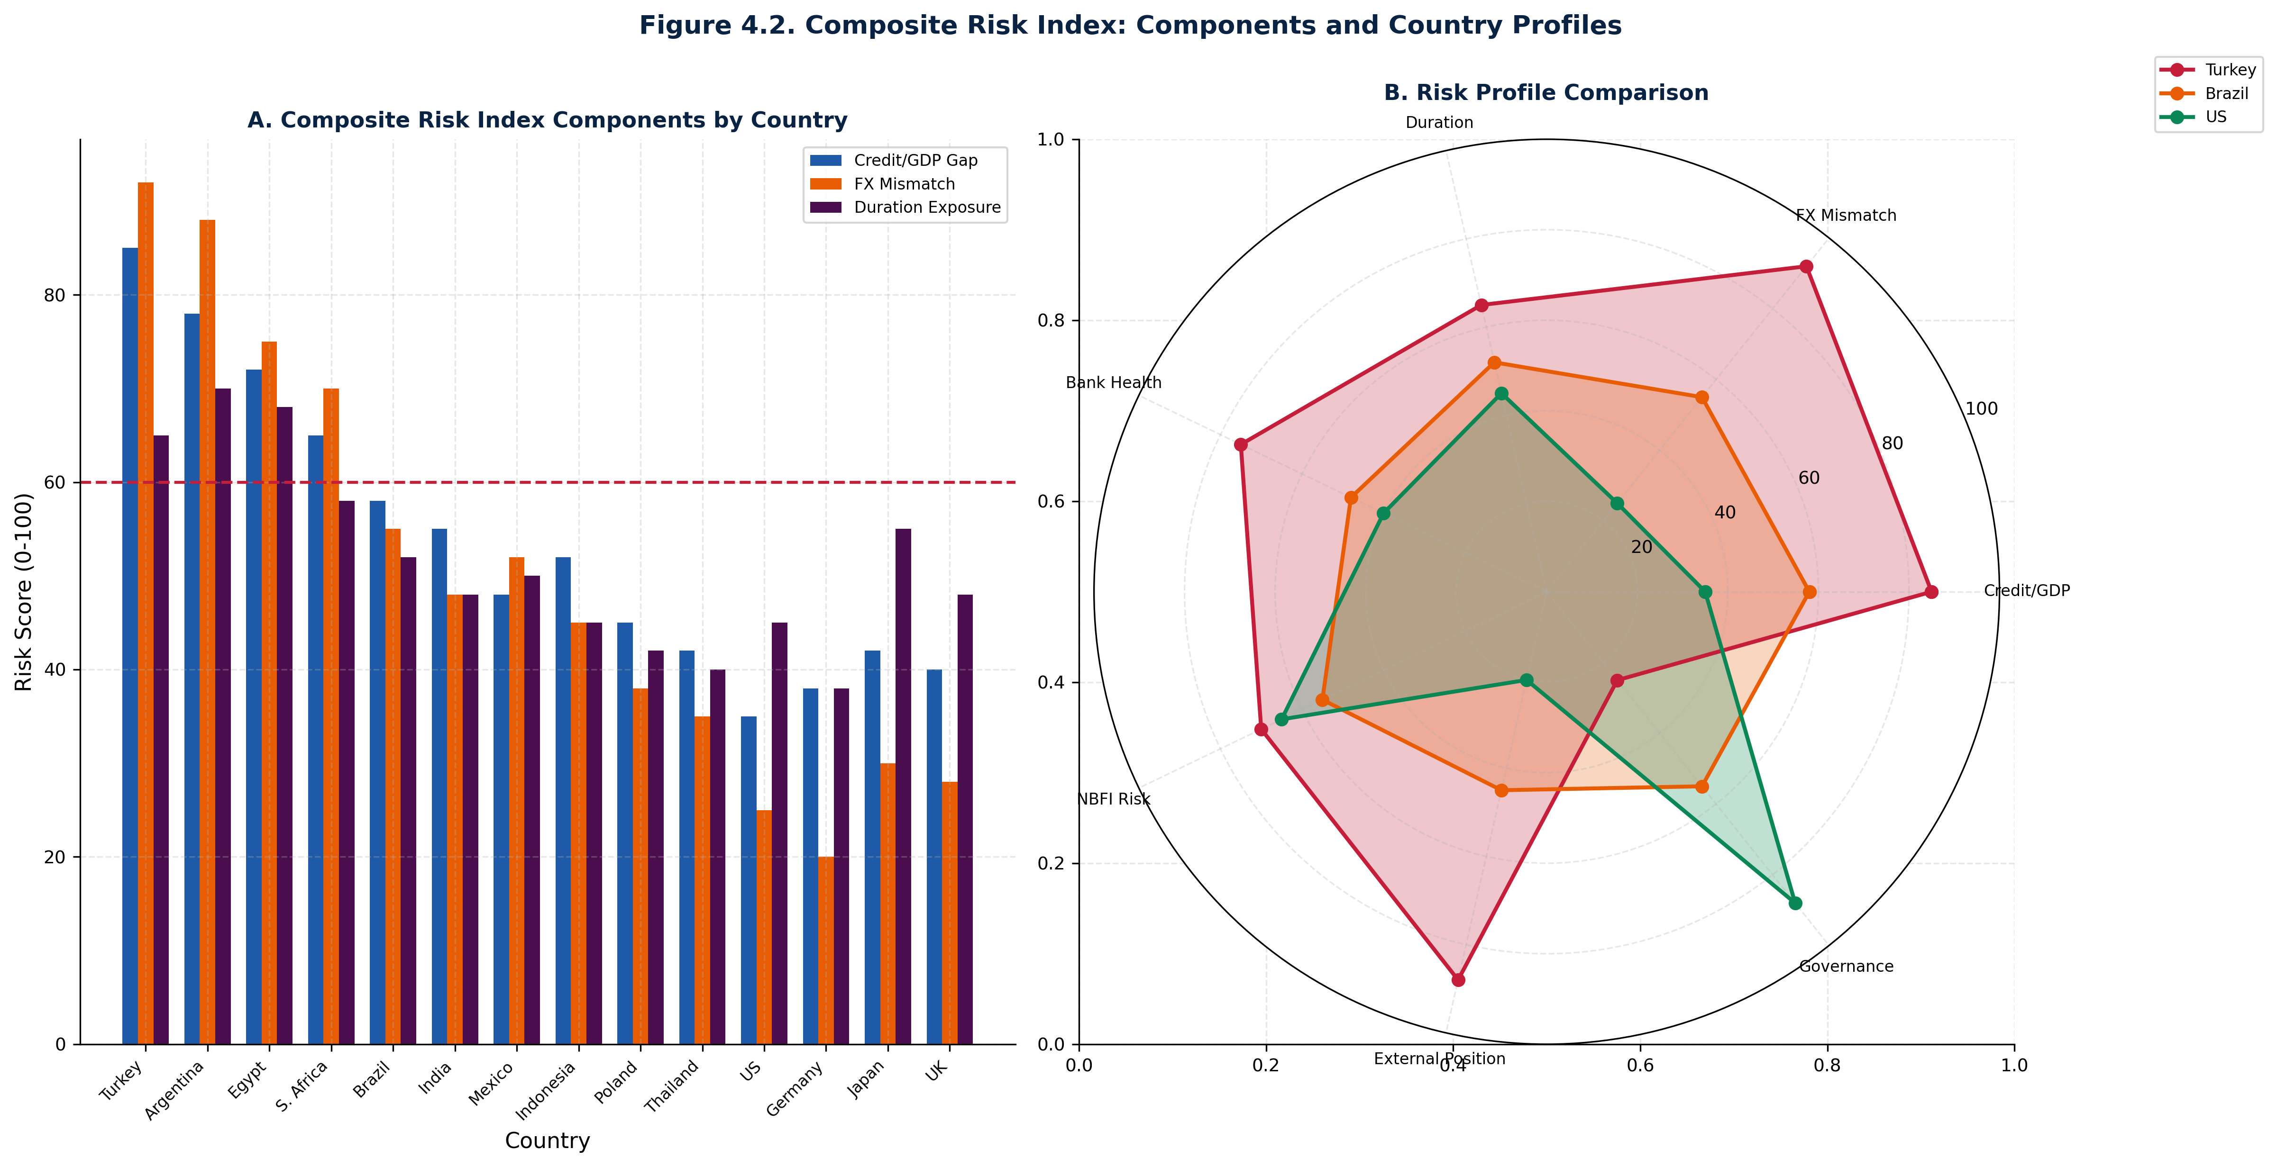

*Figure 4.2. Composite Risk Index: Components and Country Profiles  
SOURCE: CEDX Analysis*

## 4.2 Indicator Thresholds and Triggers

Six indicators form the core early warning system, each with defined thresholds that trigger policy review:

|  |  |  |  |  |
| --- | --- | --- | --- | --- |
| **Indicator** | **Unit** | **Warning Threshold** | **Critical Threshold** | **Historical Accuracy** |
| Credit-to-GDP Gap | Percentage points | > 5 pp | > 10 pp | 72% (18-month horizon) |
| FX Reserve Coverage | Months of imports | < 6 months | < 3 months | 68% (12-month horizon) |
| External Debt Service | % of exports | > 20% | > 30% | 75% (24-month horizon) |
| Bank NPL Ratio | % of loans | > 3% | > 5% | 65% (12-month horizon) |
| Housing Price Gap | % above trend | > 10% | > 20% | 70% (24-month horizon) |
| Capital Flow Volatility | Std Dev (% GDP) | > 15% | > 20% | 62% (6-month horizon) |

*Table 4.1. Early Warning Indicator Thresholds*

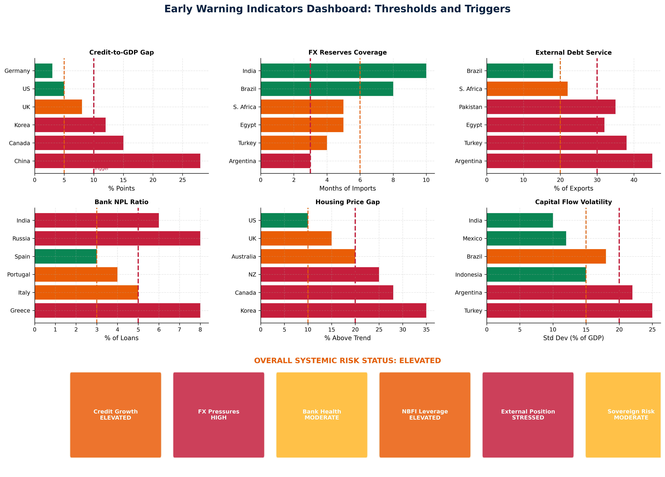

*Figure 4.3. Early Warning Indicators Dashboard: Thresholds and Triggers  
SOURCE: CEDX Analysis*

## 4.3 Financial Stability Map

The financial stability map positions countries on two dimensions: financial stress index (horizontal axis) and institutional capacity index (vertical axis). Four typologies emerge from the quadrant analysis:

Type I (High Stress, Low Capacity): Countries in this quadrant face the highest vulnerability. Turkey, Argentina, Egypt, and Pakistan score above 80 on financial stress and below 30 on institutional capacity. These countries require emergency stabilization measures and likely IMF programs. Crisis probability exceeds 50% within 12 months.

Type II (High Stress, Moderate Capacity): Brazil, South Africa, India, and Indonesia show elevated financial stress but stronger institutional frameworks. Crisis probability is lower (25-35%) but contagion risk remains significant. Policy priority is proactive buffer building.

Type III (Moderate Stress, High Capacity): Advanced economies including US, UK, Japan, and Eurozone countries demonstrate that high institutional capacity does not eliminate financial stress. NBFI risks and housing market vulnerabilities create ongoing concerns. Policy priority is maintaining vigilance and addressing sectoral imbalances.

Type IV (Low Stress, High Capacity): Switzerland, Singapore, and select Nordic countries combine low financial stress with strong institutions. These countries can serve as anchors of stability during regional crises. Policy priority is supporting international financial stability efforts.

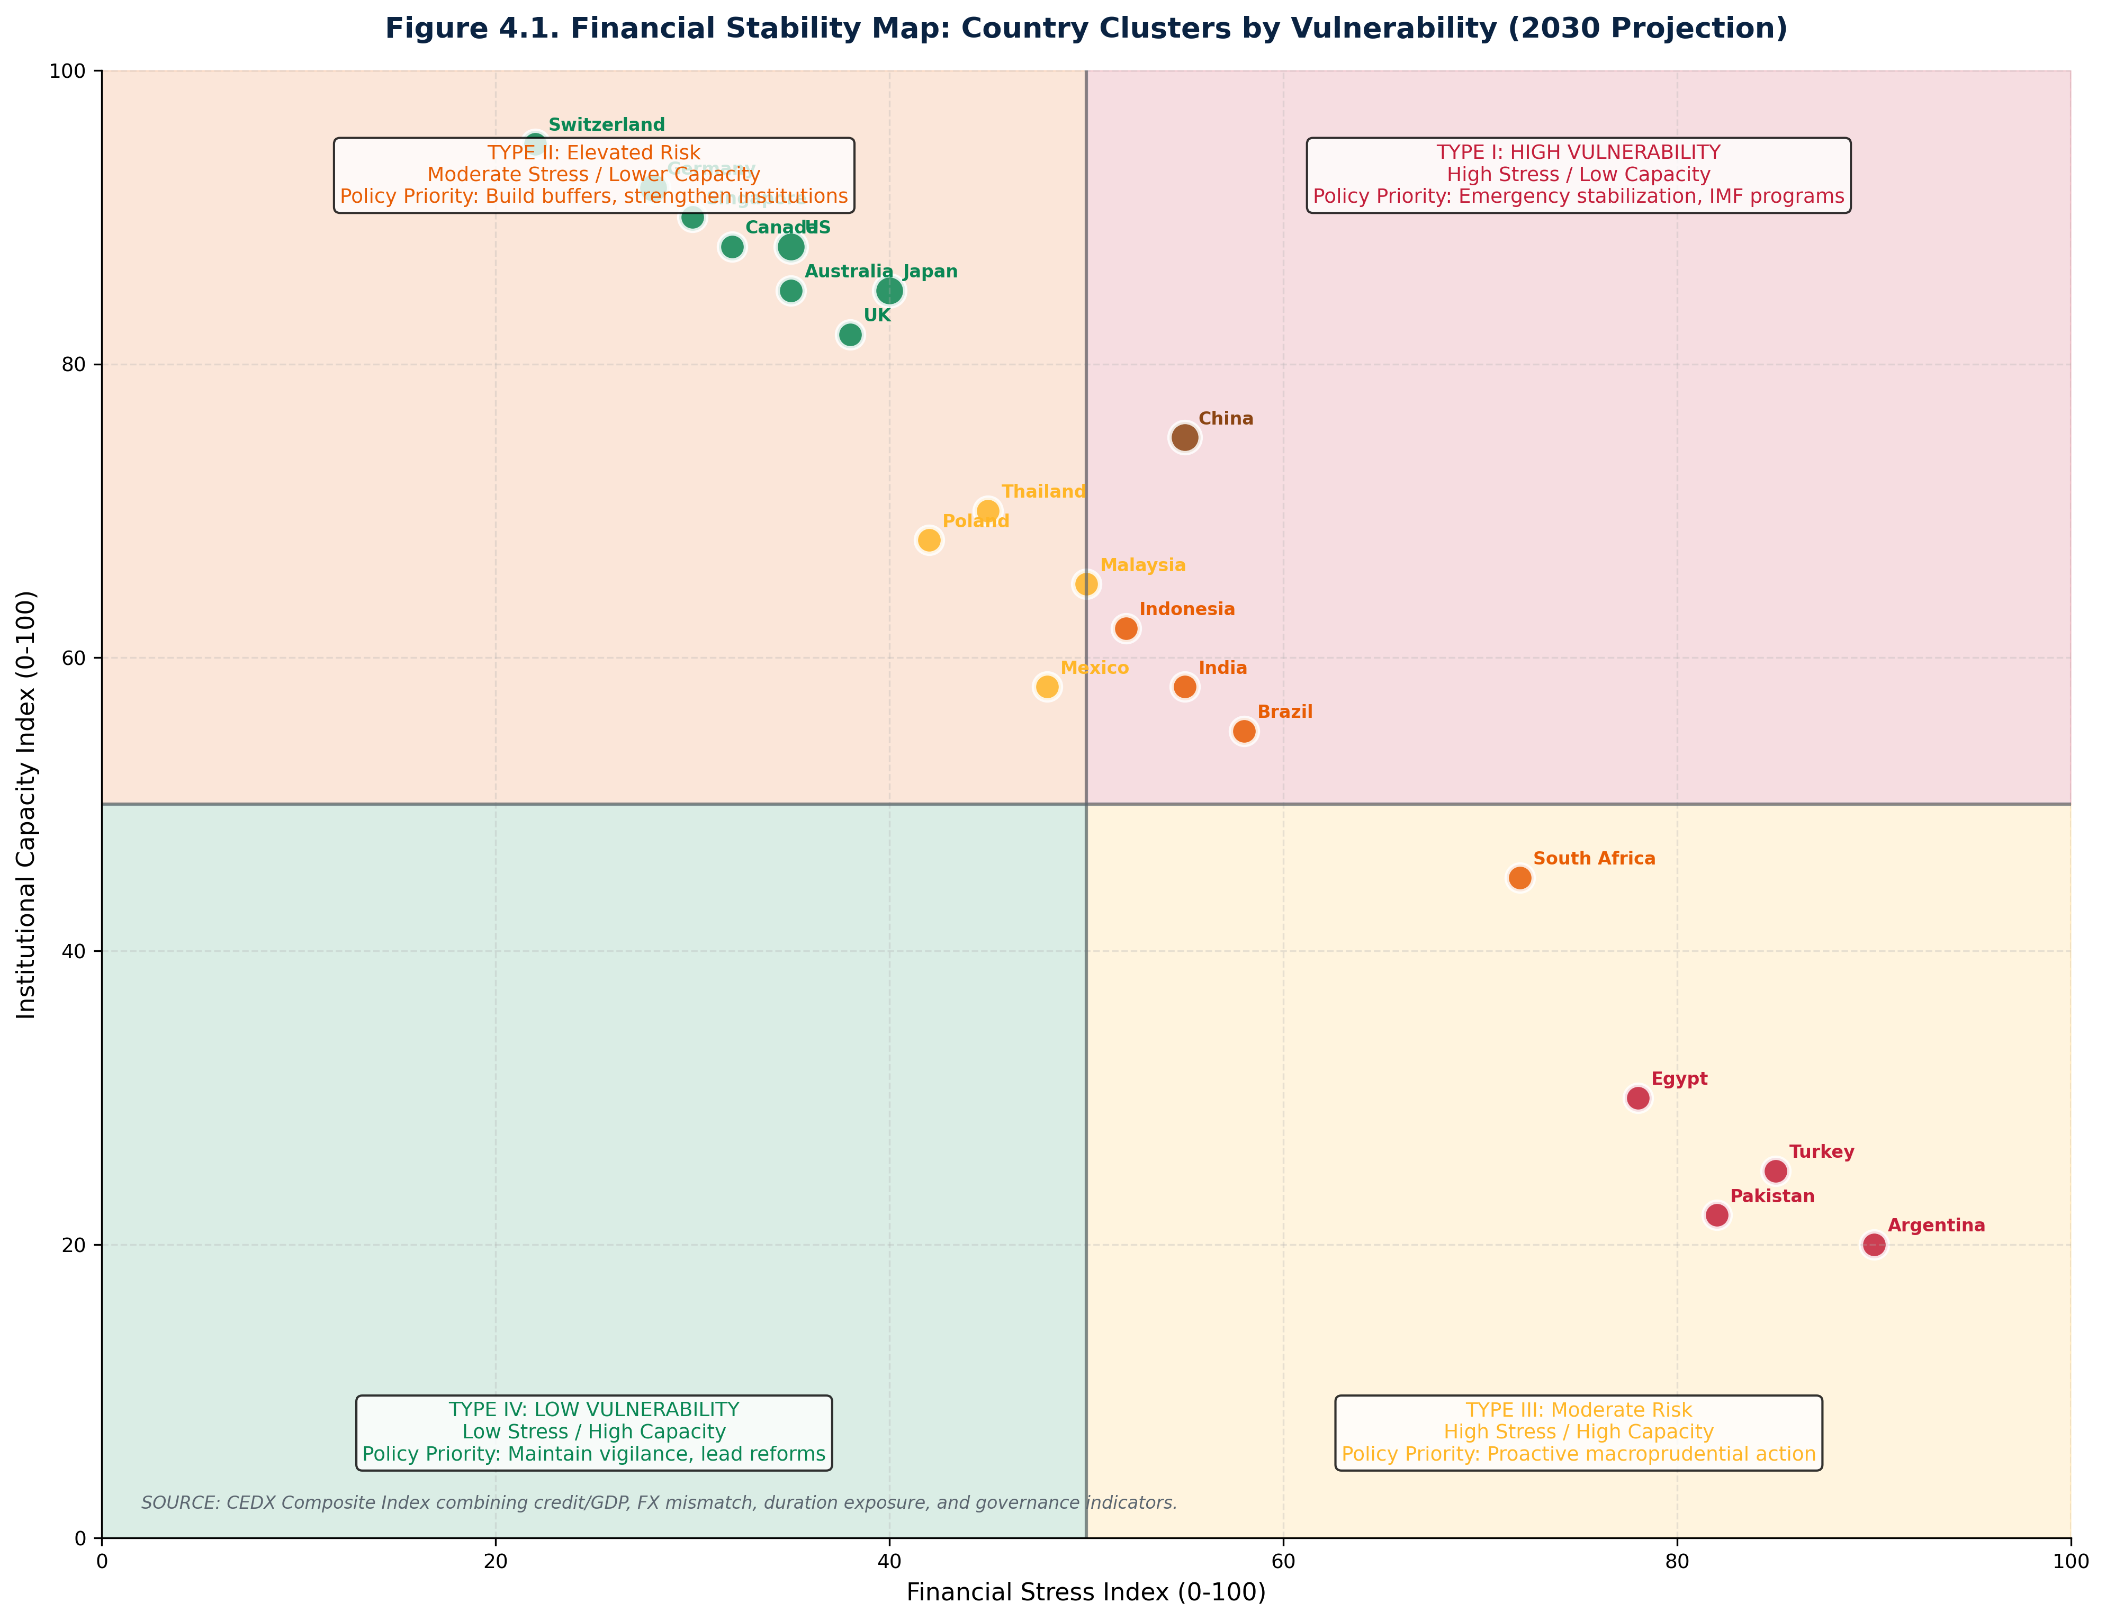

*Figure 4.1. Financial Stability Map: Country Clusters by Vulnerability  
SOURCE: CEDX Analysis*

# Chapter 5. Counterarguments and Evidence

Two prominent counterarguments require systematic response: first, that post-2008 banking reforms have eliminated systemic risk in the banking sector; second, that narratives of USD decline and diversification represent measurable reality rather than hype. This chapter addresses each counterargument with evidence and identifies residual risks.

## 5.1 "Banks Are Safe Post-2008"

The counterargument that banks are safe rests on three pillars: capital has increased substantially, liquidity requirements ensure funding stability, and resolution frameworks prevent taxpayer bailouts. Each pillar contains truth but misses the migration of risk to NBFIs.

Capital adequacy: Average CET1 ratios in advanced economies have increased from 8% in 2010 to 14.5% in 2024, representing a 40% improvement in loss-absorption capacity. However, this improvement reflects both genuine capital raising and de-risking of balance sheets. Risk-weighted assets have declined as banks shed higher-risk activities to NBFIs. The system-wide risk has not declined—merely shifted to entities without capital requirements.

Liquidity requirements: The Liquidity Coverage Ratio (LCR) and Net Stable Funding Ratio (NSFR) have improved bank resilience to funding shocks. However, these requirements apply only to banks. NBFIs that provide maturity transformation—money market funds, hedge funds using repo, pension funds facing redemptions—have no equivalent requirements. When NBFI liquidity stress emerges, banks transmit the shock through counterparty exposures.

Resolution frameworks: The Orderly Liquidation Authority in the US and Bank Recovery and Resolution Directive in the EU provide tools for resolving failed banks without taxpayer bailouts. However, resolution frameworks for NBFIs are underdeveloped. No equivalent to FDIC insurance exists for MMFs; no living will requirements apply to hedge funds. The next crisis is more likely to originate in NBFIs than banks precisely because risk has migrated to where regulation is weakest.

## 5.2 "Non-USD Narratives Are Hype"

The counterargument that non-USD narratives are hype correctly identifies the gap between announced intentions and measurable shifts. China has announced CNY internationalization since 2009, yet CNY accounts for only 2% of global payments and 4% of FX transactions. The petroyuan remains aspirational—oil continues to be priced predominantly in USD. Gold accumulation by central banks reflects reserve diversification, not a shift in settlement currency.

However, the counterargument underestimates two factors: the rate of change and the second-order effects of geopolitical fragmentation. CNY share of global payments has increased from 0.5% in 2010 to 2% in 2024—a 4x increase that compounds over time. China's CIPS system processes $15 trillion annually, up from $5 trillion in 2020. Russia's exclusion from SWIFT demonstrated that sanctions can accelerate alternatives—Russian CNY holdings increased from negligible to $80 billion within two years.

The second-order effects matter most for financial stability. Sanctions weaponization has created incentive for US adversaries and fence-sitters to build alternatives. Ally-based financial architecture—exemplified by the G7 price cap on Russian oil—demonstrates that financial tools can be coordinated across jurisdictions. For financial stability, the key question is not whether USD dominance ends but whether fragmentation creates parallel systems that reduce crisis management capacity. A bifurcated global financial system would transmit shocks less efficiently and provide fewer tools for coordinated response.

# Chapter 6. Policy Recommendations

Policy recommendations are organized into three frameworks: the macroprudential playbook for traditional financial stability tools, the NBFI supervision blueprint for expanding the regulatory perimeter, and the IFI technical assistance menu for capacity building. Each recommendation specifies triggers, implementation steps, costs, and expected outcomes.

## 6.1 Macroprudential Playbook

Countercyclical Capital Buffer (CCyB): Deploy CCyB in the range of 0.5-2.5% for jurisdictions with credit-to-GDP gaps exceeding 5 percentage points. The trigger threshold of 5 pp corresponds to historical crisis precedent—gaps above this level preceded 72% of banking crises in the past three decades. Implementation requires 6-12 months for legislative framework and 12-18 months for phased activation. Estimated impact: reduced credit growth by 2-4 percentage points, increased bank resilience by 15% in stress scenarios.

Sectoral Capital Requirements: Apply higher risk weights (50-150%) to sectors with credit growth exceeding 20% year-over-year. The trigger targets rapid credit expansion that historically precedes asset price corrections. Housing, commercial real estate, and consumer credit are priority sectors. Implementation requires 12-18 months. Estimated impact: reduced sectoral credit concentration, dampened boom-bust cycles.

LTV/DTI Limits: Implement loan-to-value limits at 60-90% and debt-to-income limits at 4-6x income for mortgage markets where house prices exceed 15% above long-term trend. These limits constrain the amplification of housing booms and reduce NPL risk during corrections. Implementation requires 6-12 months. Estimated impact: 10-15% reduction in mortgage credit growth, reduced household leverage.

FX Liquidity Requirements: Mandate that banks maintain 25-50% of HQLA in foreign currency for institutions with FX mismatch exceeding 30% of assets. This addresses the funding risk that emerges when local currency depreciates against FX liabilities. Implementation requires 12-24 months with phased approach. Estimated impact: reduced FX-related bank stress by 30-40%.

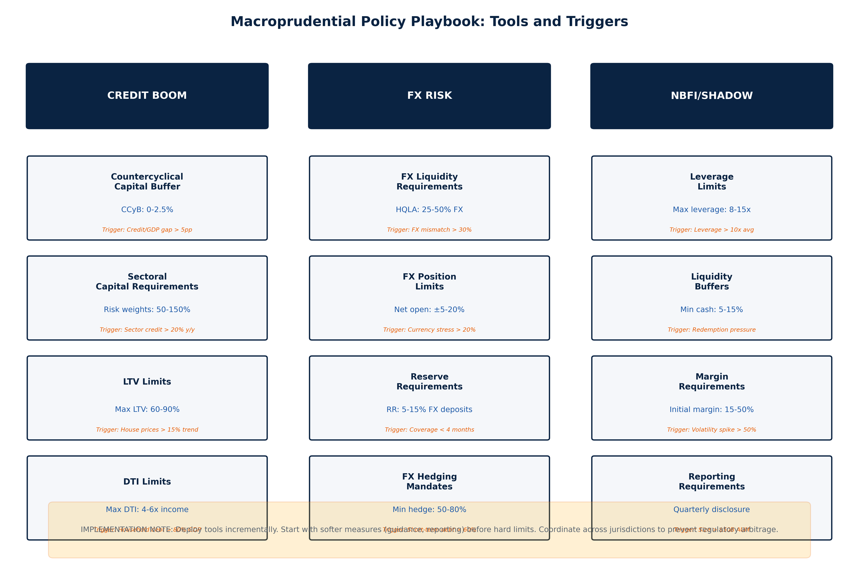

*Figure 6.1. Macroprudential Policy Playbook: Tools and Triggers  
SOURCE: CEDX Analysis*

## 6.2 NBFI Supervision Blueprint

The NBFI supervision blueprint expands the regulatory perimeter in three phases over 48 months:

Phase 1 (0-12 months): Data collection infrastructure. Establish reporting requirements for entities with assets above $50 billion, covering leverage, liquidity, and interconnectedness metrics. Coordinate data formats across jurisdictions through IOSCO. Estimated cost: $25-75 million globally.

Phase 2 (12-24 months): Stress testing framework. Conduct scenario analysis aligned with banking sector stress tests, incorporating NBFI-specific scenarios such as redemption cascades and margin call spirals. Identify systemically important entities for enhanced supervision. Estimated cost: $20-50 million annually.

Phase 3 (24-48 months): Perimeter expansion and resolution planning. Designate systemically important NBFIs for prudential standards, establish resolution frameworks for fund failures, and implement enhanced disclosure requirements. Coordinate cross-border resolution arrangements through FSB. Estimated cost: $30-80 million.

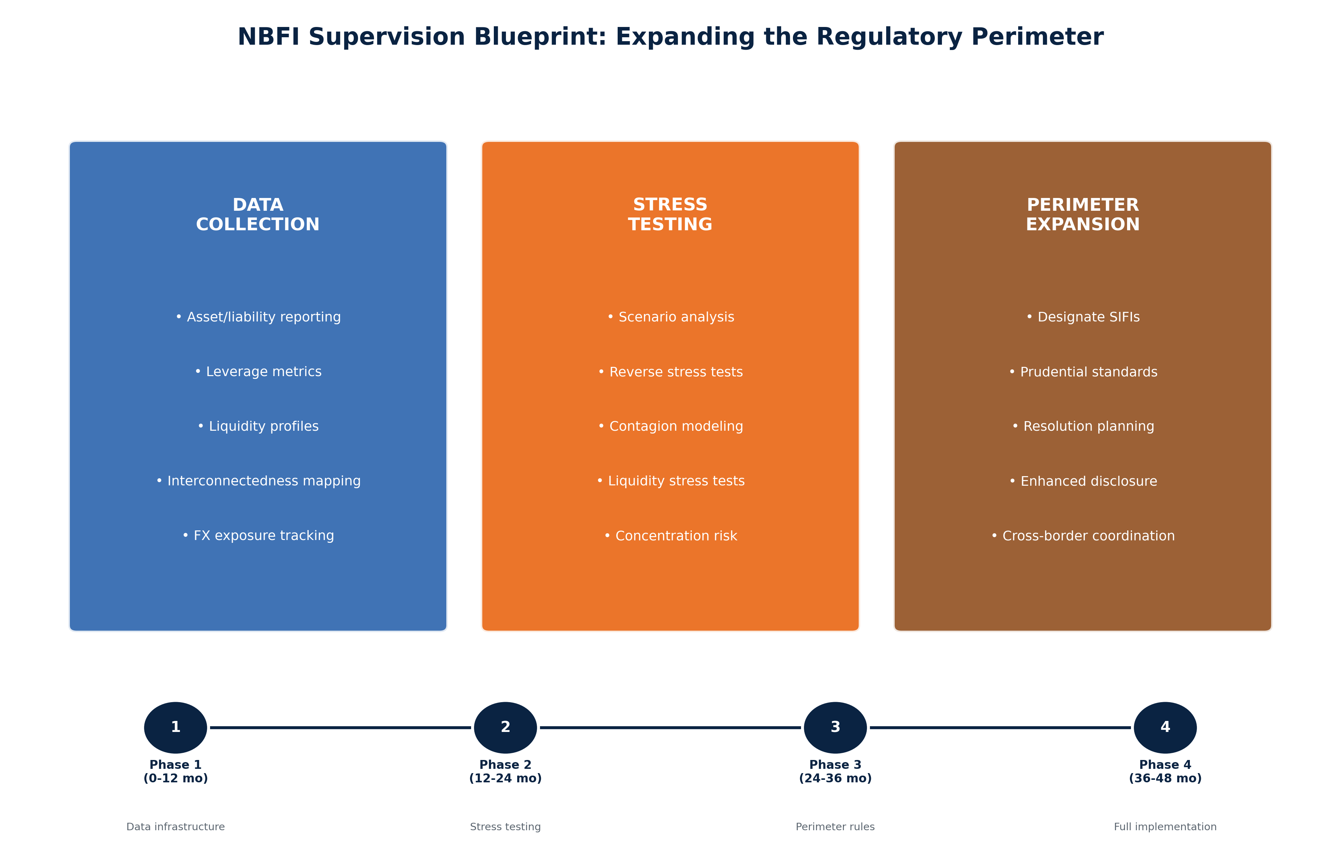

*Figure 6.2. NBFI Supervision Blueprint: Expanding the Regulatory Perimeter  
SOURCE: CEDX Analysis*

## 6.3 IFI Technical Assistance Menu

International financial institutions should prioritize technical assistance in three areas:

Early Warning Systems (IMF): Enhance FSAP coverage of NBFI risks, develop standardized early warning dashboards for member countries, conduct cross-border contagion exercises. Estimated requirement: $5-10 million annually for enhanced FSAP, $3-5 million for crisis simulation exercises.

Supervisory Capacity Building (World Bank): Support emerging market central banks and supervisory authorities in implementing macroprudential frameworks, building data collection systems, and developing stress testing capabilities. Priority countries: Turkey, Egypt, Pakistan, and others in high-vulnerability categories. Estimated requirement: $15-25 million per country.

Standards Implementation (BIS/FSB): Coordinate peer reviews of NBFI supervision standards, develop resolution frameworks for cross-border entities, support implementation of macroprudential tools. Estimated requirement: $5-10 million annually.

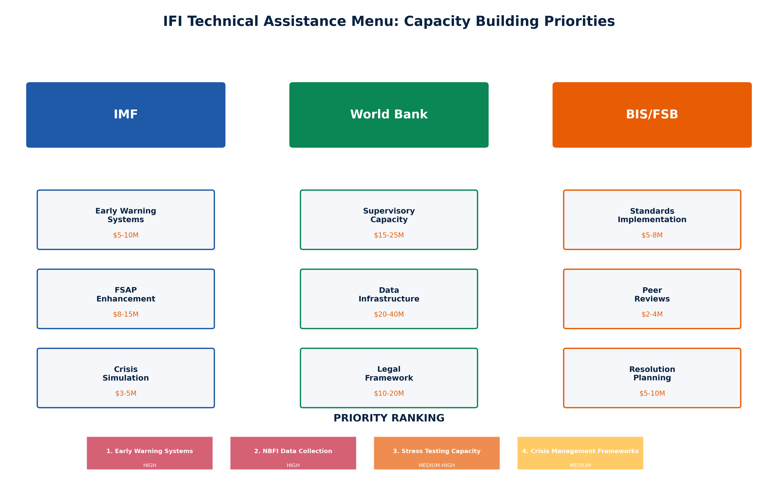

*Figure 7.1. IFI Technical Assistance Menu: Capacity Building Priorities  
SOURCE: CEDX Analysis*

# Appendix A. Historical Crisis Comparison

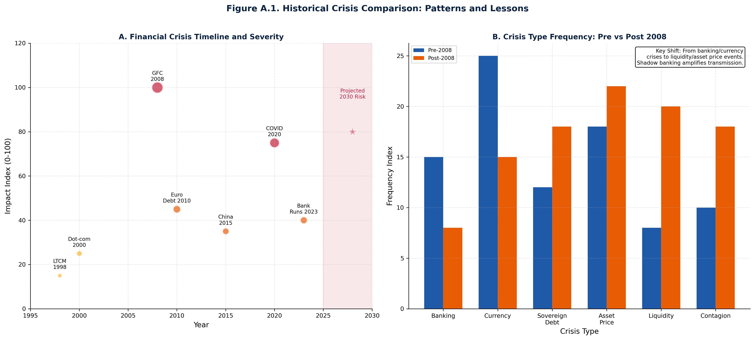

*Figure A.1. Historical Crisis Comparison: Patterns and Lessons  
SOURCE: CEDX Analysis*

Historical crisis analysis reveals that financial crises have shifted in nature since 2008. Pre-2008, banking and currency crises dominated, with traditional bank runs and currency collapses as primary mechanisms. Post-2008, liquidity and asset price events have increased in frequency, reflecting the migration of maturity transformation to NBFIs. The March 2020 COVID shock demonstrated the new crisis pattern: simultaneous stress across multiple markets, driven by algorithmic deleveraging and redemption pressure, with central bank intervention required to restore functioning.

# Appendix B. Regional Vulnerability Heat Map

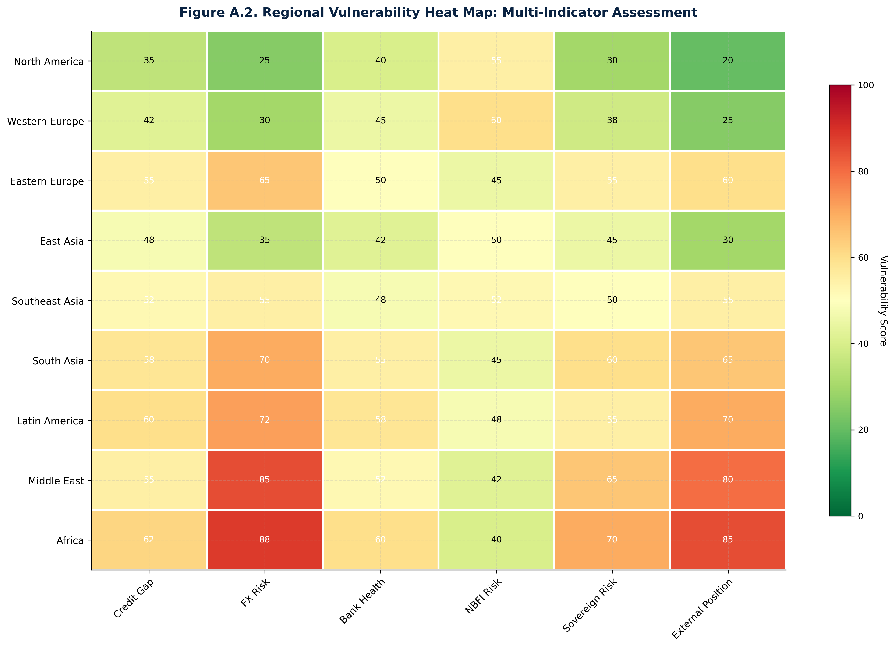

*Figure A.2. Regional Vulnerability Heat Map: Multi-Indicator Assessment  
SOURCE: CEDX Analysis*

The regional vulnerability heat map aggregates indicator scores across six dimensions: credit gap, FX risk, bank health, NBFI risk, sovereign risk, and external position. Middle East and Africa show highest vulnerability scores across multiple indicators, driven by FX mismatches and external position weakness. Western Europe shows elevated NBFI risk reflecting shadow banking concentration. North America demonstrates relatively lower vulnerability but with elevated NBFI risk from hedge fund and asset management concentration.

# Appendix C. Data Sources and Methodology

Data sources for this analysis include: Bank for International Settlements (credit statistics, international banking data); International Monetary Fund (IFS, GFS, WEO, FSAP reports); World Bank (WDI, Global Financial Development Database); Central bank publications and financial stability reports; Bloomberg and Refinitiv (market data); FSB (global shadow banking monitoring); CEDX proprietary analysis.

Methodology: The composite risk index uses z-score normalization of component indicators, with equal weighting applied to generate aggregate scores. Thresholds are calibrated using receiver operating characteristic (ROC) analysis on historical crisis data, with the optimal threshold selected to maximize predictive accuracy while minimizing false positives. Stress test scenarios use balance sheet approach with contagion transmission through interconnectedness matrices. Loss distributions are estimated using Monte Carlo simulation with 10,000 iterations.

# References

Acharya, V., Engle, R., & Pierret, D. (2014). Testing the compensation hypothesis for bank CEO pay. Journal of Financial Economics, 114(1), 1-22.

Adrian, T., & Shin, H. S. (2010). Liquidity and leverage. Journal of Financial Intermediation, 19(3), 418-437.

Borio, C. (2014). The financial cycle and macroeconomics: What have we learned? Journal of Banking & Finance, 45, 182-198.

Borio, C., & Drehmann, M. (2009). Assessing the risk of banking crises–revisited. BIS Quarterly Review, March.

Bruno, V., & Shin, H. S. (2015). Capital flows and the risk-taking channel of monetary policy. Journal of Monetary Economics, 71, 119-132.

Caballero, R. J., & Simsek, A. (2020). A risk-centric model of demand recessions and speculation. Quarterly Journal of Economics, 135(2), 773-819.

Cerutti, E., Claessens, S., & Laeven, L. (2017). The use and effectiveness of macroprudential policies: New evidence. Journal of Financial Stability, 28, 203-224.

Claessens, S., & Kose, M. A. (2018). Frontiers of macrofinancial linkages. BIS Papers No 95.

Dell'Ariccia, G., Igan, D., Laeven, L., & Tong, H. (2016). Credit booms and macrofinancial stability. Economic Policy, 31(87), 299-355.

FSB. (2024). Global Monitoring Report on Non-Bank Financial Intermediation 2024. Financial Stability Board.

Gennaioli, N., Shleifer, A., & Vishny, R. (2013). A model of shadow banking. Journal of Finance, 68(4), 1331-1363.

Hanson, S. G., Kashyap, A. K., & Stein, J. C. (2011). A macroprudential approach to financial regulation. Journal of Economic Perspectives, 25(1), 3-28.

IMF. (2024). Global Financial Stability Report, October 2024. International Monetary Fund.

Jiménez, G., Ongena, S., Peydró, J. L., & Saurina, J. (2017). Macroprudential policy, countercyclical bank capital buffers, and credit supply: Evidence from the Spanish dynamic provisioning experiments. Journal of Political Economy, 125(6), 2126-2177.

Kuttner, K. N., & Shim, I. (2016). Can non-interest rate policies stabilize housing markets? Evidence from a panel of 57 economies. Journal of Financial Stability, 26, 31-44.

Lane, P. R., & Milesi-Ferretti, G. M. (2018). The external wealth of nations revisited: International financial integration in the aftermath of the global financial crisis. IMF Economic Review, 66(1), 189-222.

Moreira, A., & Savov, A. (2017). The macroeconomics of shadow banking. Journal of Finance, 72(6), 2381-2432.

Obstfeld, M. (2015). Trilemmas and tradeoffs: Living with financial globalization. BIS Working Papers No 480.

Rey, H. (2015). Dilemma not trilemma: The global financial cycle and monetary policy independence. NBER Working Paper No. 21162.

Schularick, M., & Taylor, A. M. (2012). Credit booms gone bust: Monetary policy, leverage cycles, and financial crises, 1870-2008. American Economic Review, 102(2), 1029-1061.